**Computer Networks Lab 3**

**Name: Vaibhav Chaudhari**

**ID: 2017B5A70834G**

**Q1. Customize your Wireshark**

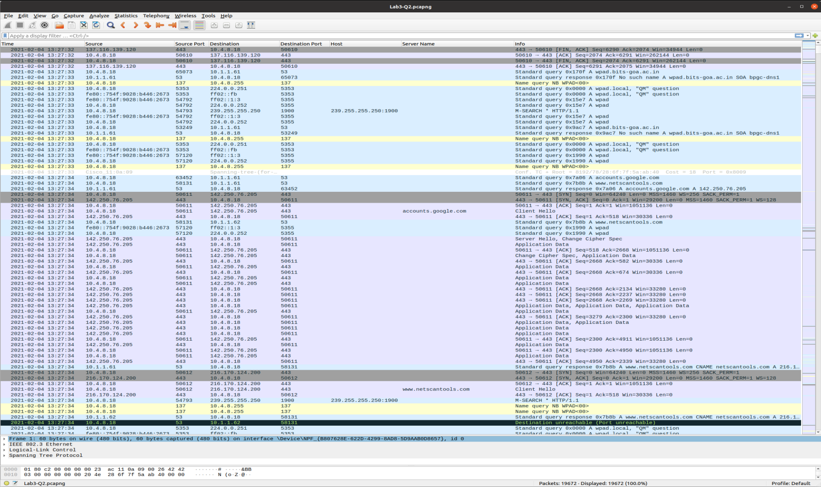

The preferences were set as follows:

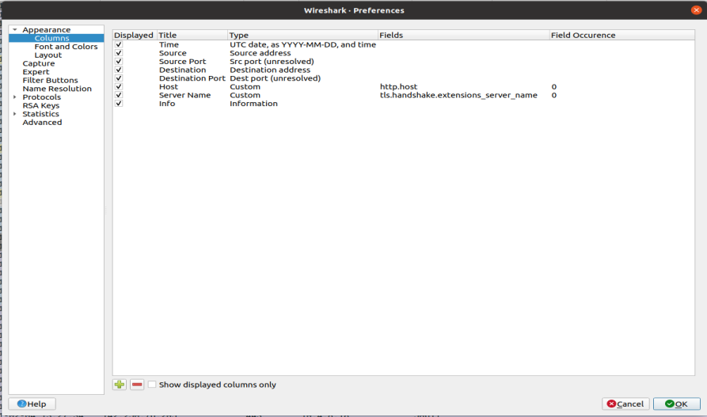

**Q2. Wireshark dump analysis**

1. **Identify the http request packet**

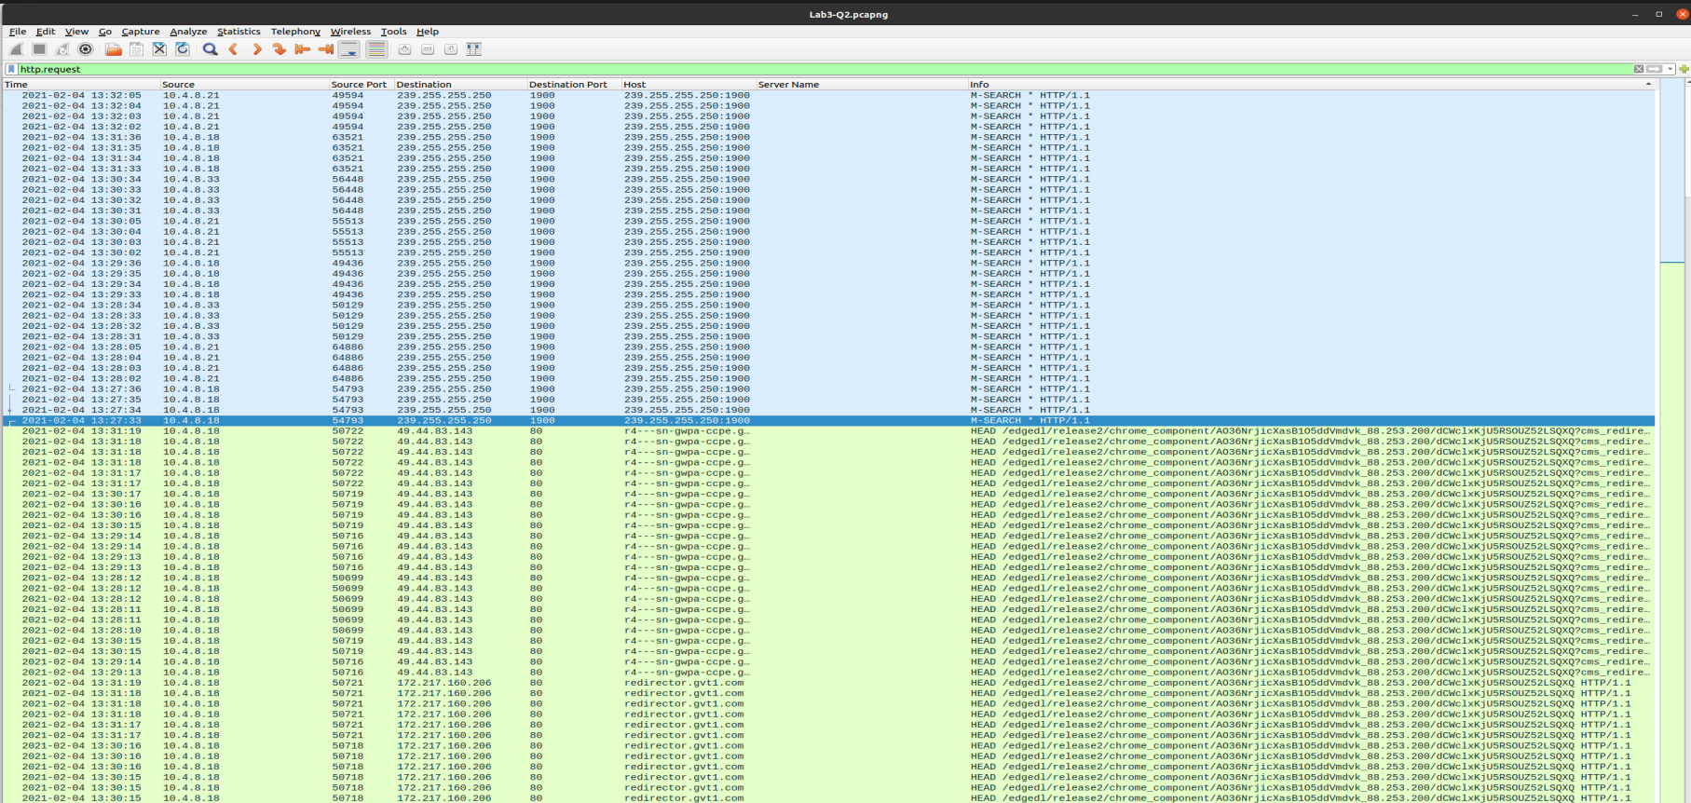

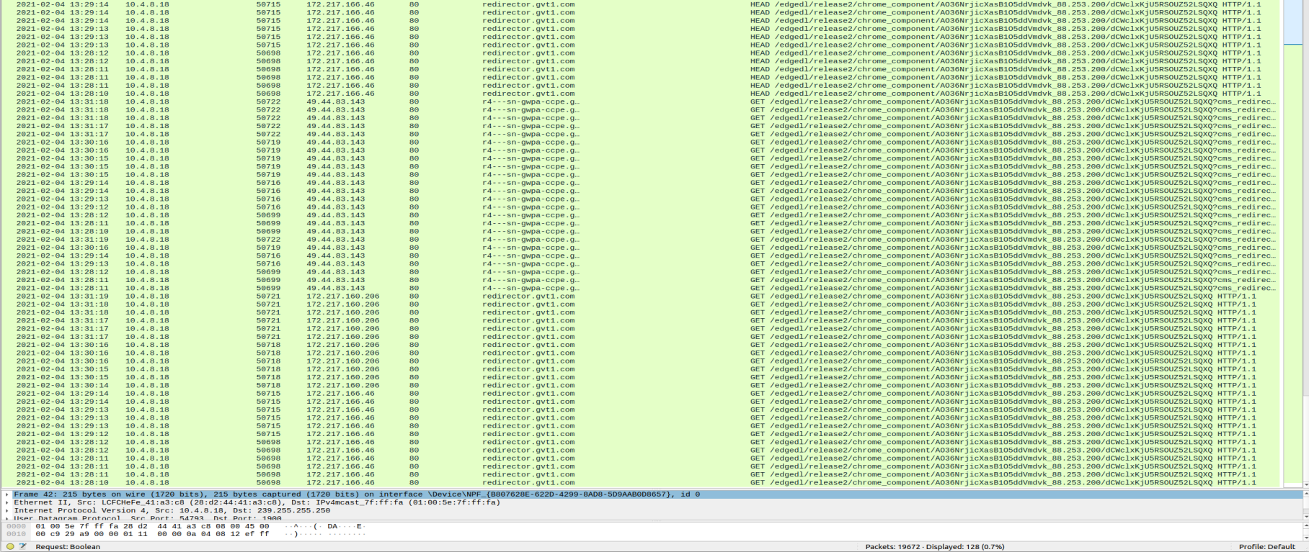

The filter used here is the **http.request.** This tells us the list of all requests that are made.

1. **Identify the http response packet**

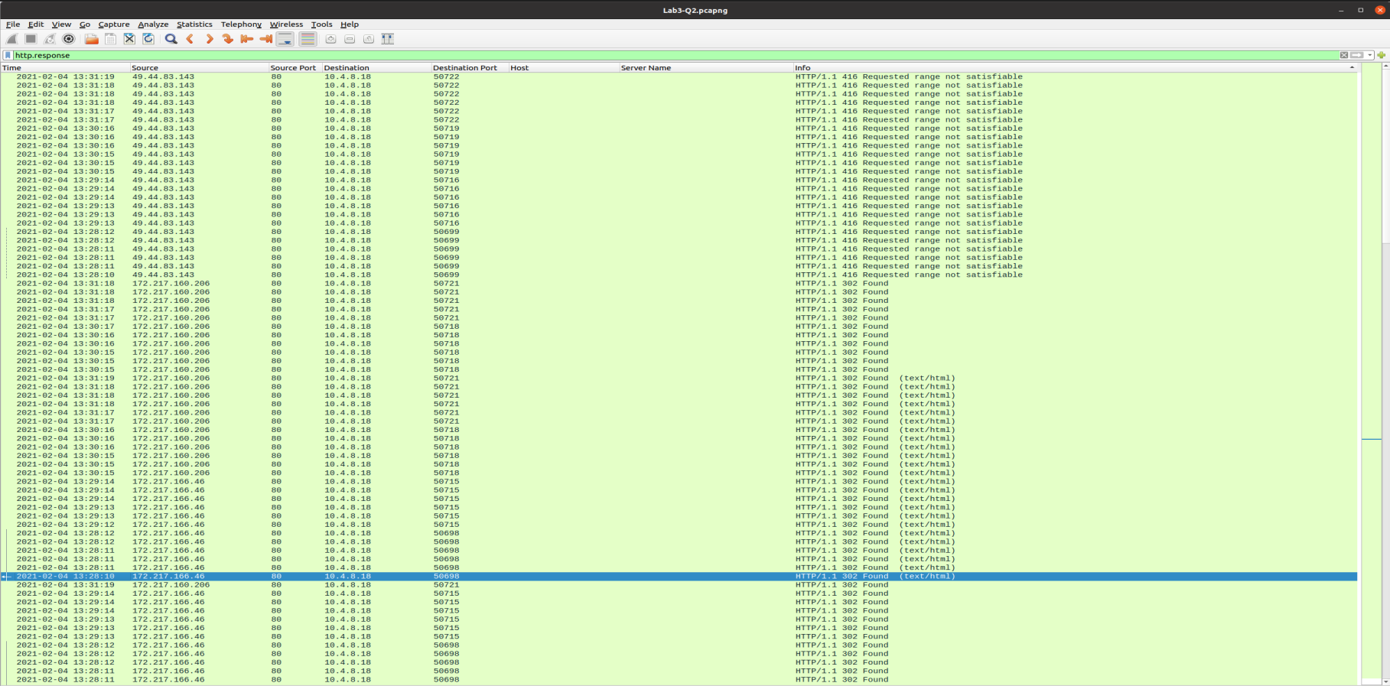

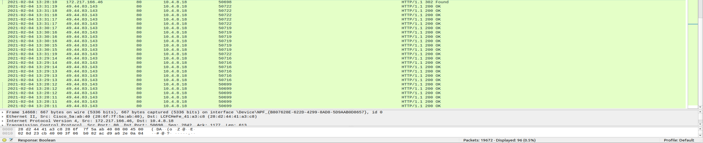

The filter used here is **http.response.** This tells us the list of all the responses. We can see that the destination address for all the packets are the same.

1. **Display the statistics of the TCP and UDP packets**

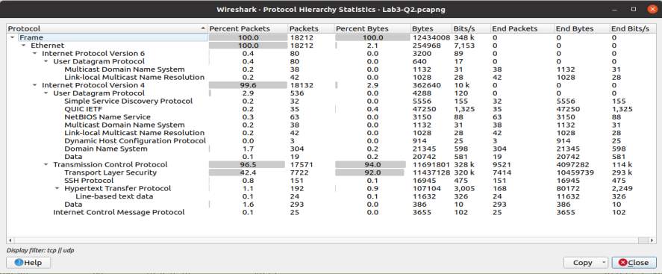

The filter used here is **udp || tcp**.We can get this by going to **Protocol Hierarchy** option in the **Statistics** Menu. This gives us a detailed report on the number of packets and their percentage.

1. **List out the TCP packets whose syn. and ack. Flags are on.**

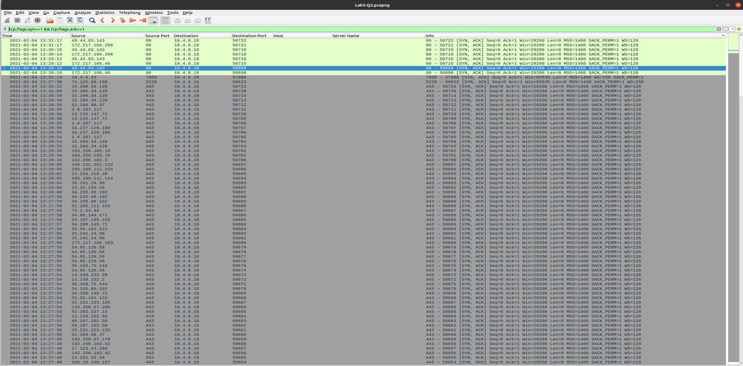

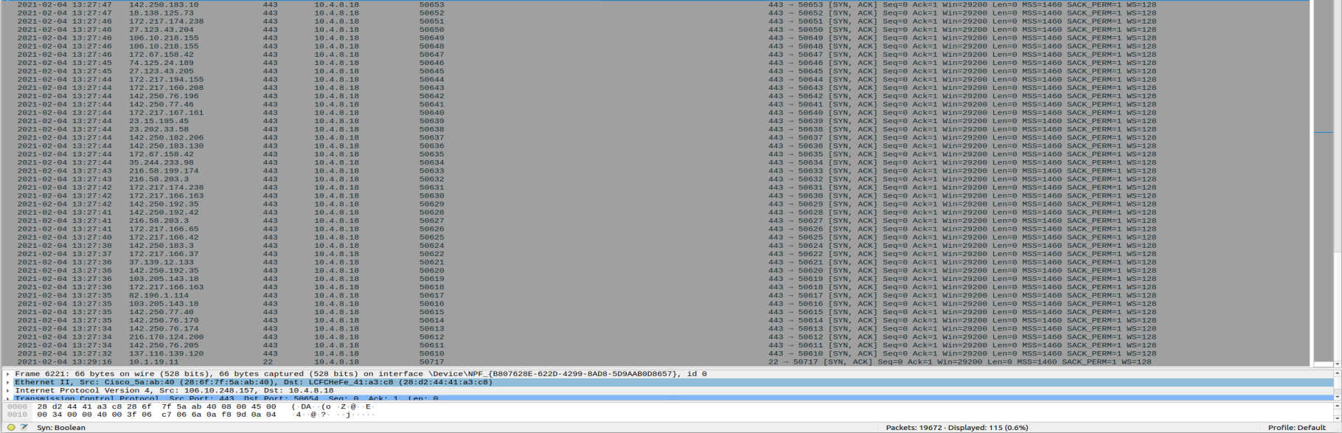

The filter used here is **tcp.flags.syn==1 && tcp.flags.ack==1**

For the flags to be on, they have to be set to 1 so we check all the tcp packets whose syn. and ack. flags are set to 1.

1. **List out the TCP and UDP packets where destination port=80.**

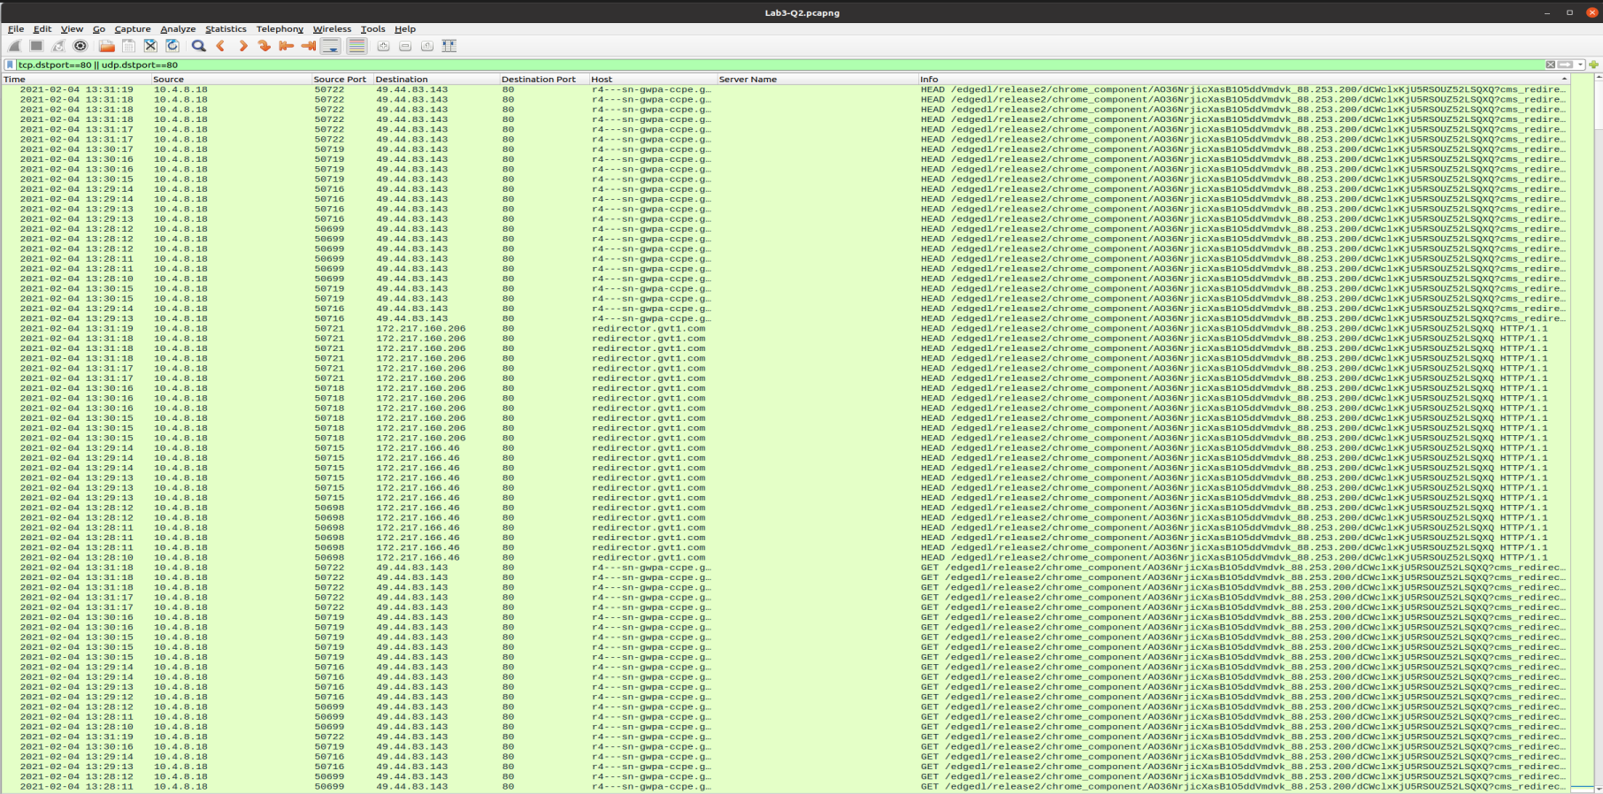

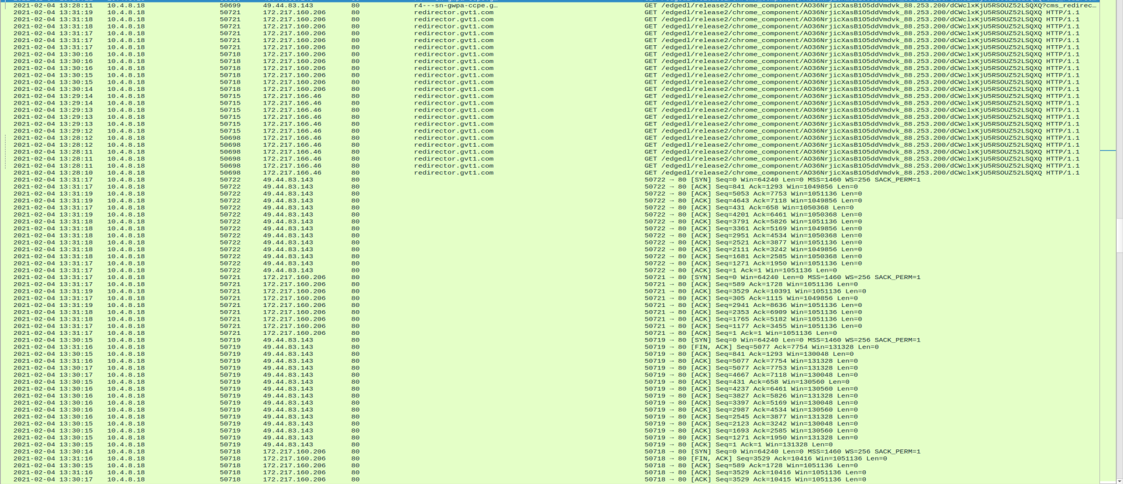

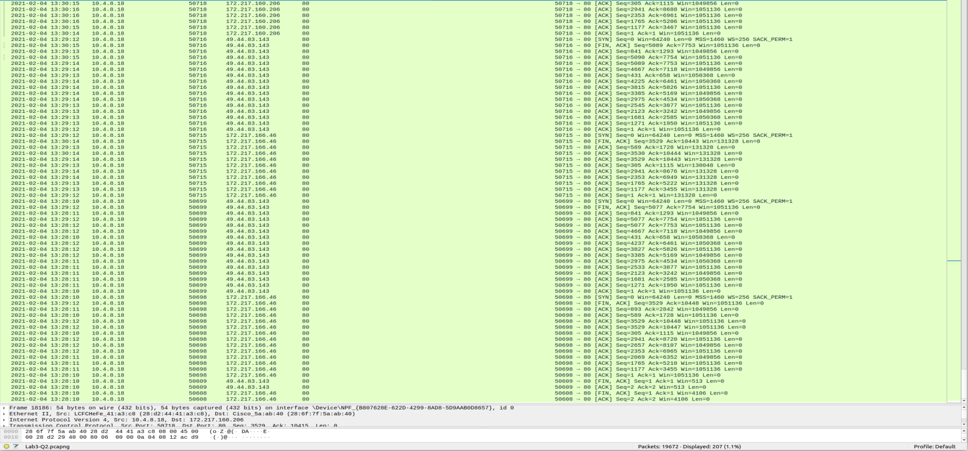

The filter used here is **tcp.dstport==80 || udp.dstport==80.** We use dstport to check if the destination port is 80 for the tcp and udp connections.

1. **List out the ARP packets.**

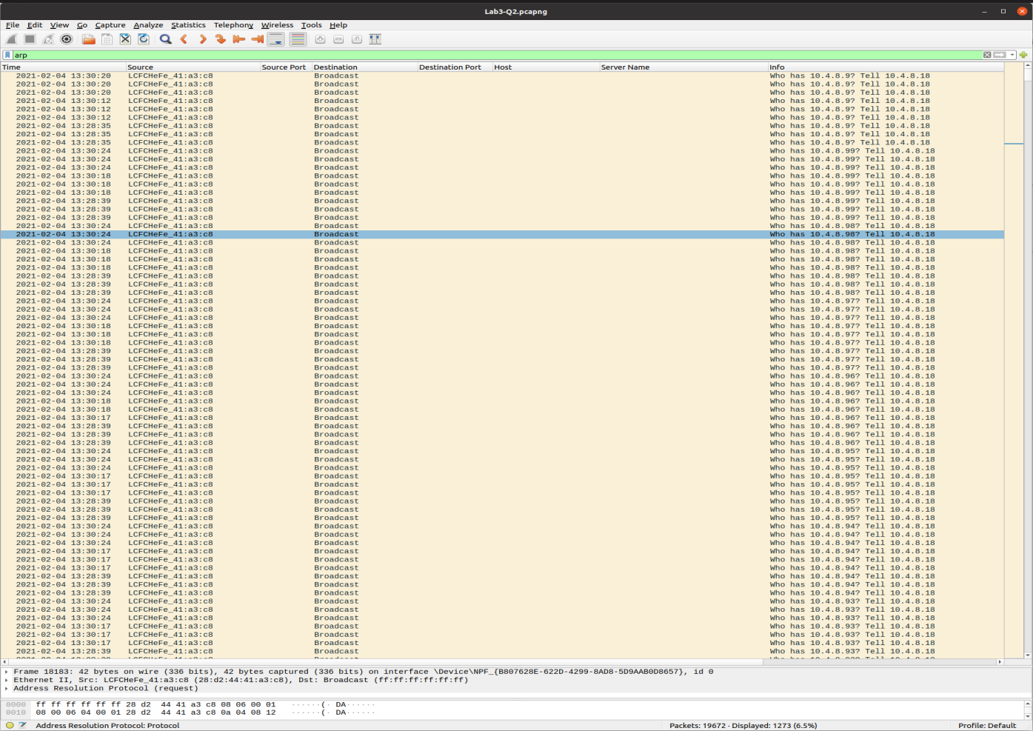

The filter used here is **arp.** The ARP(Address Resolution Protocol) is used to see the mapping between a layer 3 (protocol) and a layer 2 (hardware) address.